Test Application: https://demo.testfire.net/
Date: July 19, 2025
Test Type: Security Vulnerability Testing

Test Case 1: SQL Injection Authentication Bypass
Test Case ID:01
Test Case Title: Verify SQL Injection vulnerability in login authentication
Vulnerability Type: SQL Injection
Test Priority: High
Severity: Critical
Pre-conditions:
- Navigate to https://demo.testfire.net/
- Application login page is accessible
- No user is currently logged in
Test Steps:
- Open the login page at https://demo.testfire.net/index.jsp
- In the Username field, enter the SQL injection payload: ' OR '1'='1
- In the Password field, enter any value (e.g., "anything")
- Click on the "Login" button
- Observe the application response
Expected Results:
- Login should fail with invalid credentials
- Error message should be displayed
- User should remain on login page
Actual Results:
- Application logs the user in as Admin
- Authentication bypass successful
- User gains unauthorized access to administrative functions
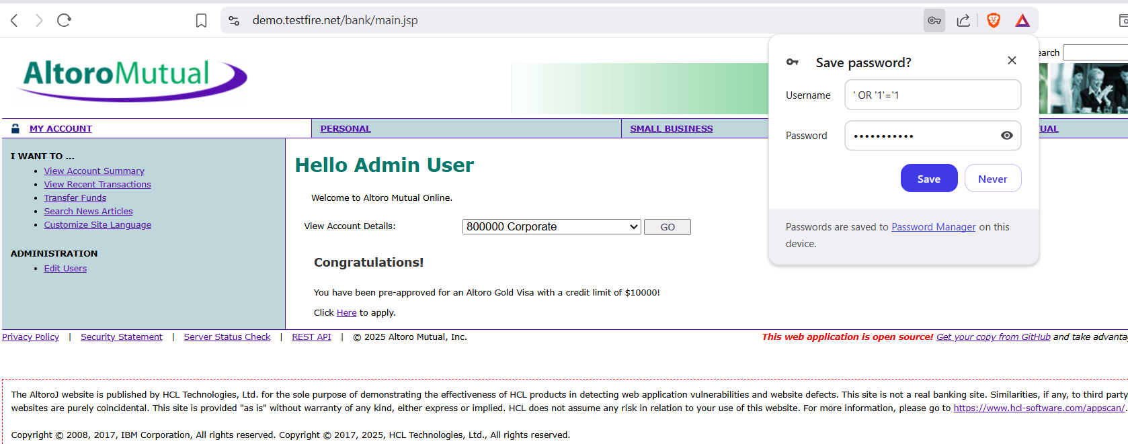
Impact Description: An attacker can bypass login authentication without valid credentials and gain unauthorized access to administrative or user accounts. This could lead to data theft, manipulation, or complete compromise of the system.
Recommended Fix:
- Use prepared statements (parameterized queries) instead of concatenating SQL strings
- Implement robust input validation and sanitization for all user inputs
- Use ORM frameworks that abstract direct SQL queries
- Apply least privilege access to database users
- Perform regular security testing and code reviews

Test Case 2: Cross-Site Scripting (XSS) in Search Field
Test Case ID: TC_SEC_002
Test Case Title: Verify XSS vulnerability in search functionality
Vulnerability Type: Cross-Site Scripting (XSS)
Test Priority: High
Severity: High
Pre-conditions:
- Navigate to https://demo.testfire.net/
- Application homepage is loaded
- Search functionality is available
Test Steps:
- Open the TestFire homepage at https://demo.testfire.net/
- Locate the search field on the page
- Enter the XSS payload: <script>alert('Hacked!');</script>
- Submit the search query
- Observe the application response
Expected Results:
- Search query should be sanitized
- No JavaScript execution should occur
- Search results or error message should be displayed safely
Actual Results:
- JavaScript alert box pops up displaying "Hacked!"
- XSS payload executes successfully
- User input is not properly sanitized
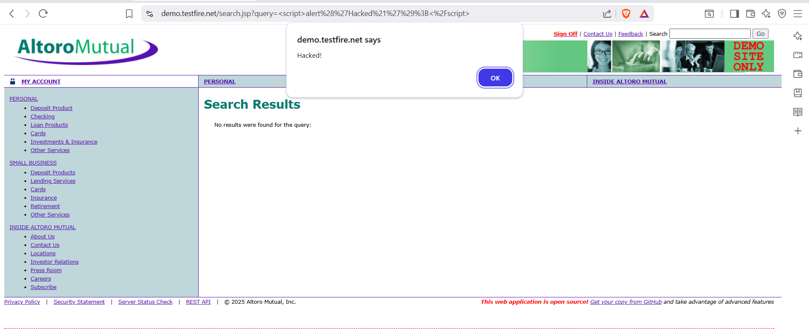
Impact Description:
- Attackers can inject arbitrary scripts into web pages
- Users may be exposed to phishing, session hijacking, or redirection to malicious sites
- Compromises user data security and application trust
- Can lead to cookie theft and session manipulation
Recommended Fix:
- Sanitize input by removing or escaping script-related tags and attributes
- Encode output using proper HTML encoding libraries before rendering user input
- Implement Content Security Policy (CSP) headers
- Use a Web Application Firewall (WAF) to detect and block malicious payloads
- Validate and filter all user inputs on both client and server side

Test Case 3: Sensitive Data Exposure in Account Details
Test Case ID: TC_SEC_003
Test Case Title: Verify exposure of sensitive account information
Vulnerability Type: Sensitive Data Exposure
Test Priority: Critical
Severity: Critical
Pre-conditions:
- Navigate to https://demo.testfire.net/
- Valid user credentials are available (jsmith/demo1234)
- User account has associated bank accounts
Test Steps:
- Open the TestFire homepage at https://demo.testfire.net/
- Login using credentials: Username: "jsmith", Password: "demo1234"
- Navigate to the Welcome page after successful login
- Click on "View Account Details" for different accounts
- Examine the account information displayed
- Check if full account numbers are visible
- Navigate to Transfer funds page
- Observe account number display in dropdown menus
Expected Results:
- Account numbers should be masked (e.g., --****-1234)
- Only last 4 digits should be visible to user
- Sensitive financial data should be protected from exposure
Actual Results:
- Full account numbers are displayed in clear text
- Complete sensitive financial information is exposed
- No masking or protection of account details implemented
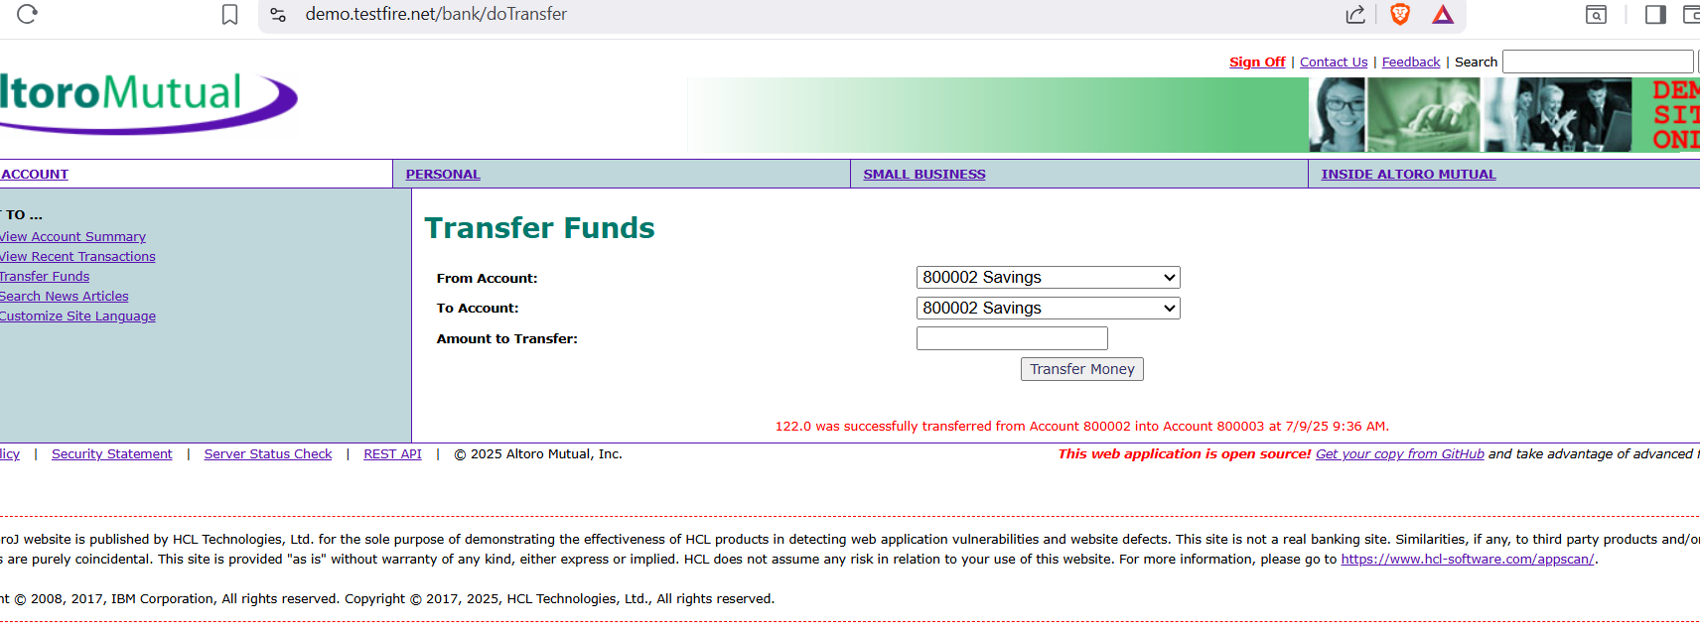
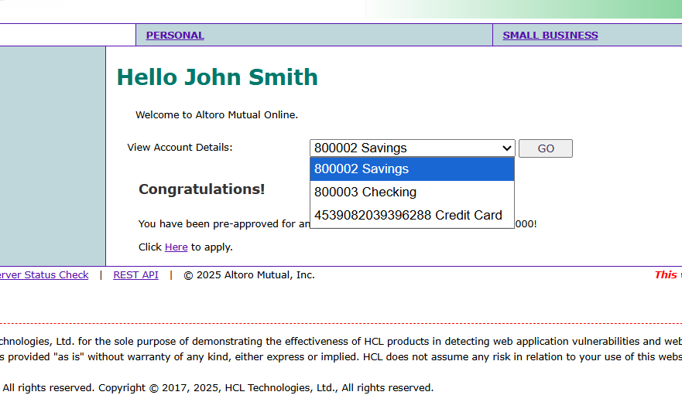
Impact Description:
- Information leakage risk through shoulder surfing attacks
- Easy access to sensitive data via browser inspection tools or XSS attacks
- Compliance violations with standards like PCI DSS
- Potential for account fraud and financial crimes
- Privacy violations and regulatory non-compliance
Recommended Fix:
- Display only the last 4 digits of account numbers (e.g., --****-6288)
- Implement data masking for all sensitive financial information
- Limit sensitive data exposure on frontend interfaces
- Secure API responses to return masked values for UI components
- Implement proper encryption for sensitive data transmission
- Regular security audits and compliance assessments

